**SECTION A**

1. Give any one common root vegetable used in the preparation of sauce at home.

_________________________________________________________

1. How is the work of a switch different from that of a fuse in an electric circuit?

_________________________________________________________

1. Sanitation is the general cleanliness of an area. State any one material / item used in keeping the environment clean.

_________________________________________________________

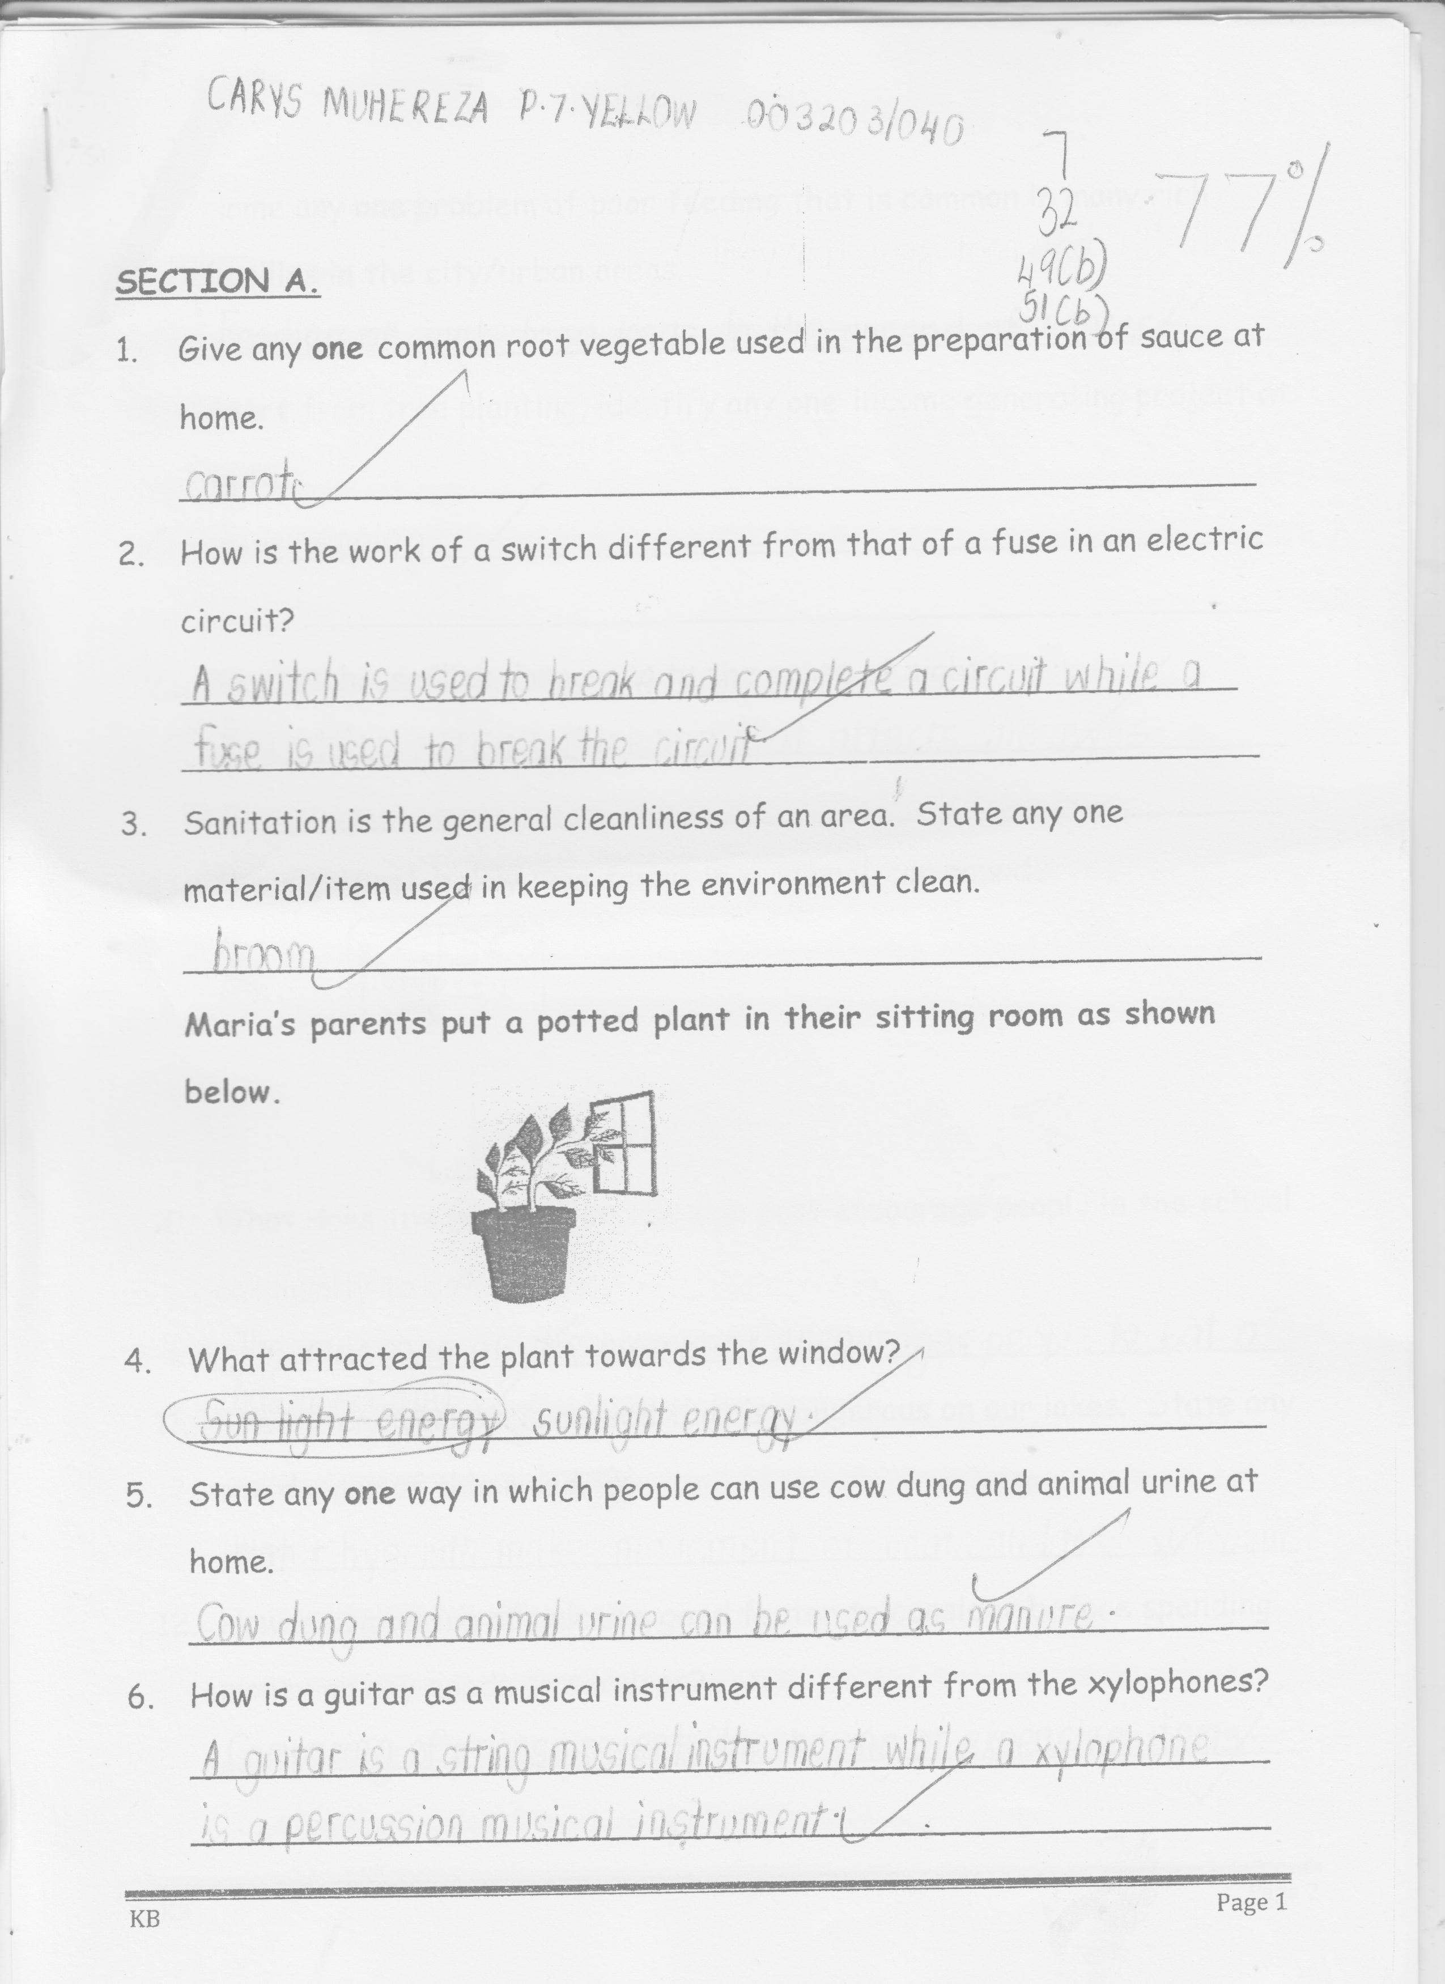**Maria’s parents put a potted plant in their sitting room as shown below**

1. What attracted the plant towards the window?

_________________________________________________________

1. State any one way in which people can use cow dung and animal urine at home.

_________________________________________________________

1. How is a guitar as a musical instrument different from the xylophones?

_________________________________________________________

_________________________________________________________

1. Name any one problem of poor feeding that is common in many rich families in the city / urban areas.

_________________________________________________________

1. Apart from tree planting, identify any one income generating project at home.

_________________________________________________________

1. How are houseflies dangerous to the sense of sight?

_________________________________________________________

**The sign post below was found in a school compound**

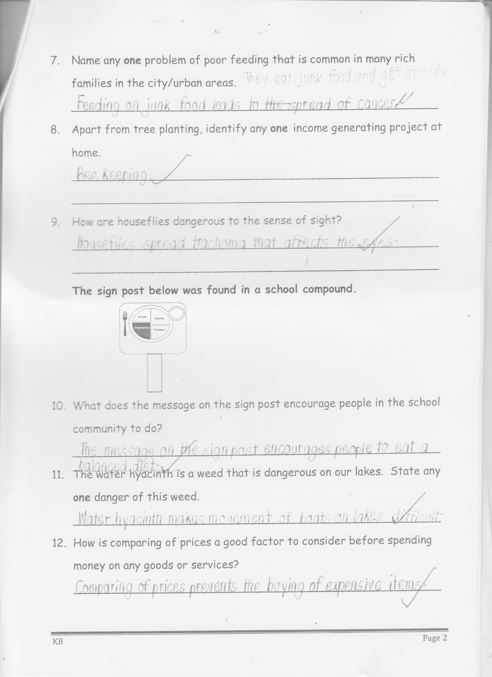

1. What does the message on the sign post encourage people in the school community to do?

_________________________________________________________

1. The water hyacinth is a weed that is dangerous on our lakes. State any one danger of this weed.

_________________________________________________________

1. How is comparing of prices a good factor to consider before spending money on any goods or services?

_________________________________________________________

**The diagram below shows a property of Air.**

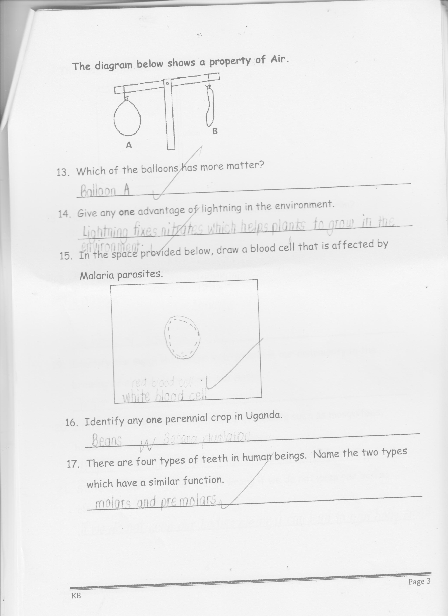

1. Which of the balloons has more matter?

_________________________________________________________

1. Give any one advantage of lightning in the environment.

_________________________________________________________

1. **In the space provided below, draw a blood cell that is affected by**

**Malaria parasites.**

1. Identify any one perennial crop in Uganda.

_________________________________________________________

1. There are four types of teeth in human beings. Name the two types which have a similar function.

i)________________________________________________________

ii)_______________________________________________________

**The diagram below is of a cylindrical tank**

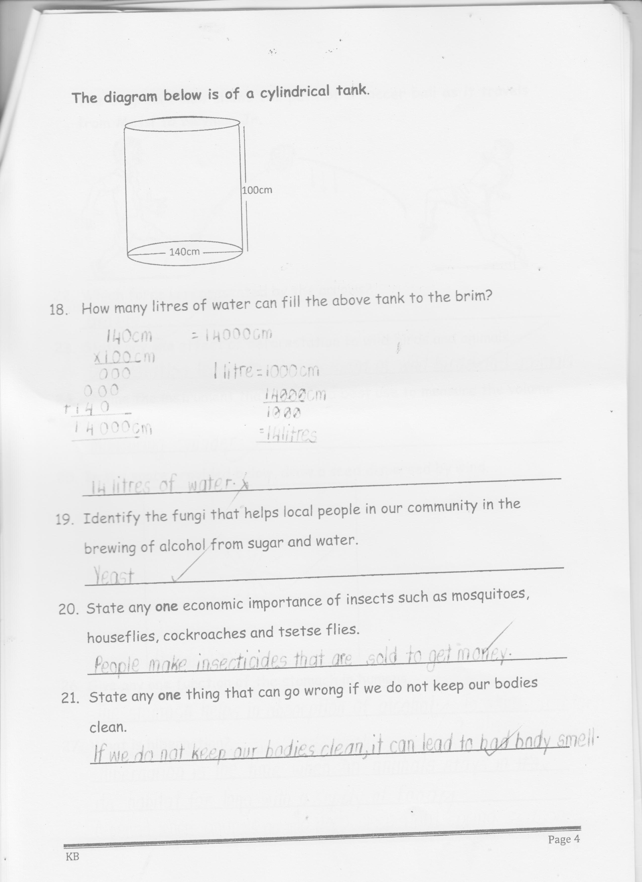

1. How many litres of water can fill the above tank to the brim?

_________________________________________________________

1. Identify the fungi that helps local people in our community in the brewing of alcohol from sugar and water.

_________________________________________________________

1. State any one economic importance of insects such as mosquitoes. houseflies, cockroaches and tsetse flies.

_________________________________________________________

1. State any one thing that can go wrong if we do not keep our bodies clean.

_________________________________________________________

**The diagram below shows the path of a soccer ball as it travels from Mess to Neymar Jr.**

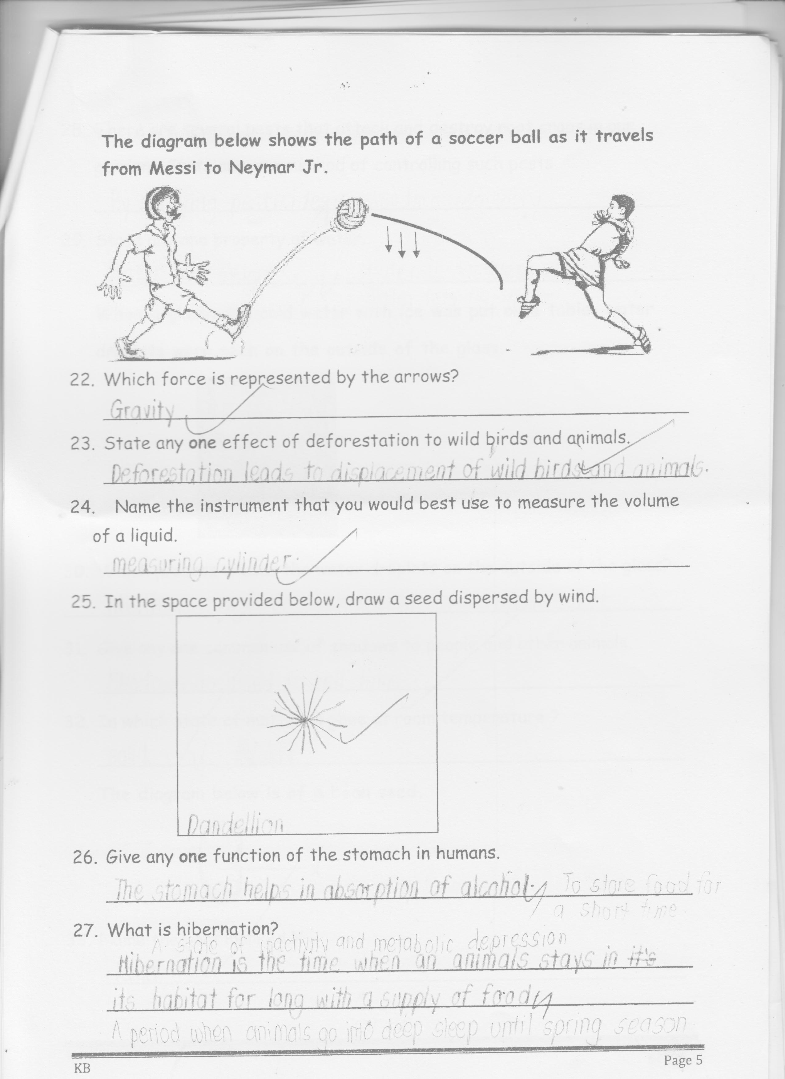

1. Which force is represented by the arrows?

_________________________________________________________

1. State any one effect of deforestation to wild birds and animals.

_________________________________________________________

1. Name the instrument that you would best use to measure the volume of a liquid.

_________________________________________________________

1. In the space provided below, draw a seed dispersed by wind
2. Give any one function of the stomach in humans.

_________________________________________________________

1. What is hibernation?

_________________________________________________________

_________________________________________________________

1. There are several pests that attack and destroy root crops in our garden. State any one method of controlling such pests.

_________________________________________________________

1. State any one property of water

_________________________________________________________

**When a glass with cold water with ice was put on a table, water droplets were seen on the outside of the glass.**

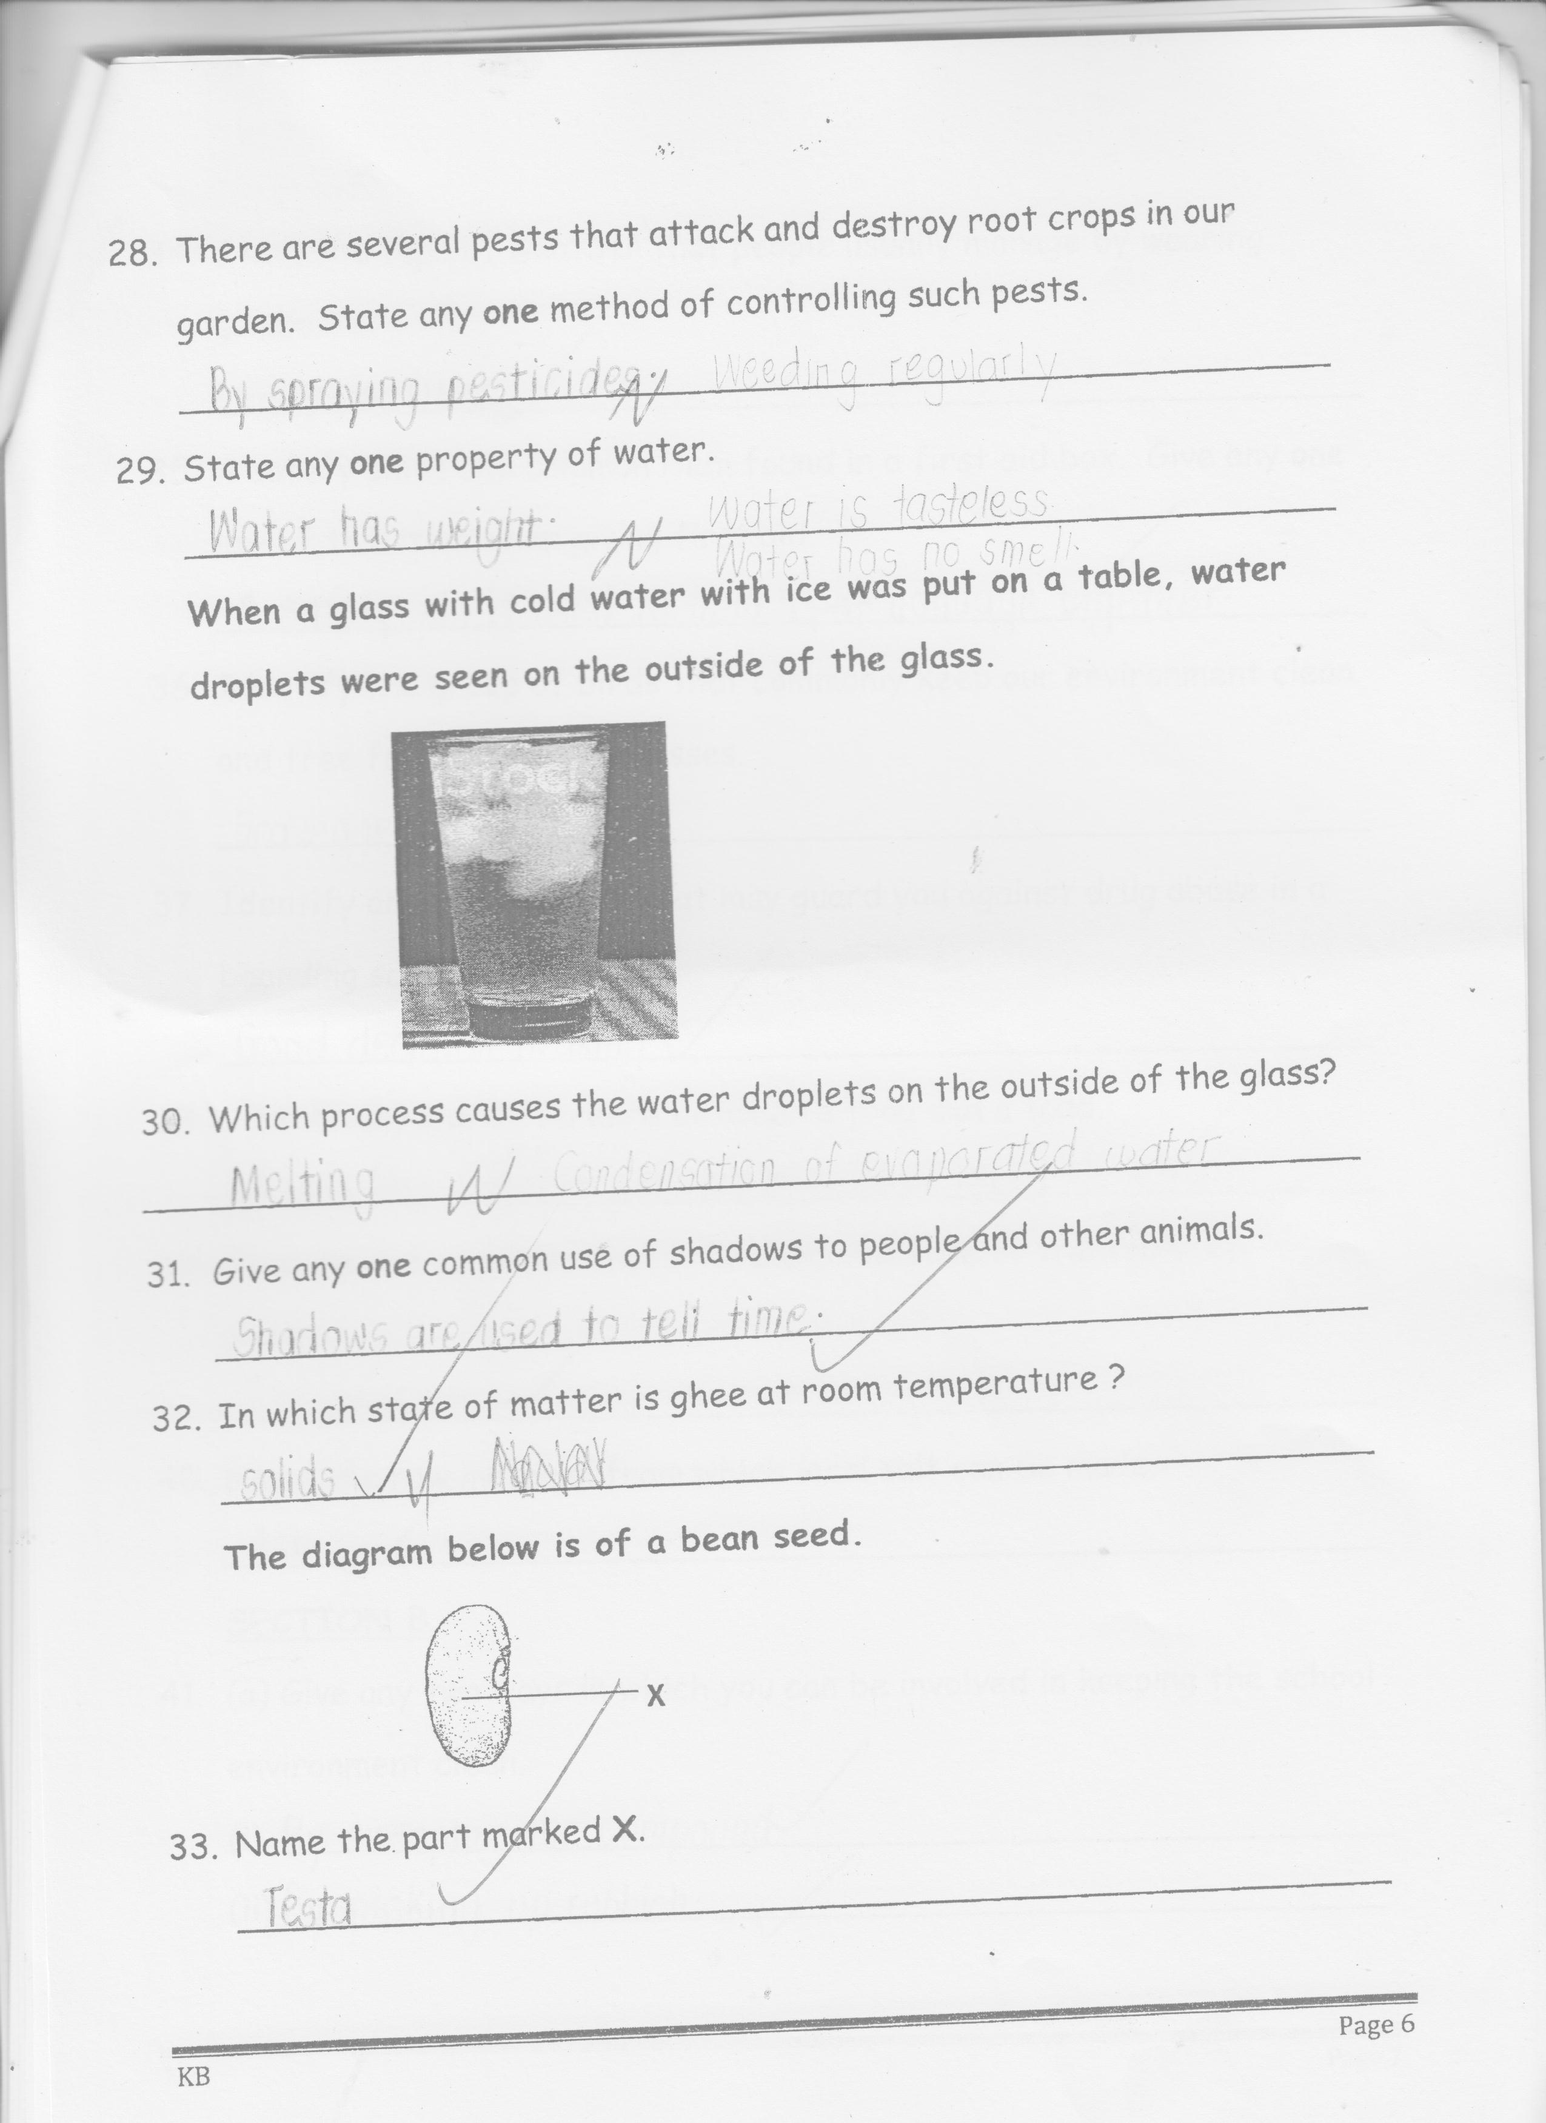

1. Which process causes the water droplets on the outside of the glass?

_________________________________________________________

1. Give any one common use of shadows to people and other animals.

_________________________________________________________

1. In which state of matter is ghee at room temperature?

_________________________________________________________

**The diagram below is of a bean seed.**



1. Name the part marked X.

_________________________________________________________

1. State the type of weather that people usually manage by wearing gumboots.

_________________________________________________________

1. A safety pin is one common item found in a first aid box. Give any one use of this item when giving first aid.

_________________________________________________________

1. Identify the group of birds that commonly keep our environment clean and free from rotting carcasses.

_________________________________________________________

1. Identify any one life skill that may guard you against drug abuse in a boarding school.

_________________________________________________________

1. State any one difference between a frog and a toad.

_________________________________________________________

_________________________________________________________

1. Give any one condition that influences the rate of transpiration in plants.

_________________________________________________________

1. Name the raw material from which local salt can be made.

_________________________________________________________

**SECTION B (60 MARKS)**

1. a) Give any two ways in which you can be involved in keeping the school

environment clean.

i)____________________________________________________

ii)___________________________________________________

b) Explain any one way school children can put to good use polythene bags

that have been picked from the school compound.

______________________________________________________

c) Why is it important for the sports teacher to plant grass in patched

areas on the field or play ground?

______________________________________________________

1. a) What is the cause of the following immunizable diseases?
2. Hepatitis B

_________________________________________________

1. Haemophilus Influenza b.

_________________________________________________

b) Name the major body organ that is affected by Hepatitis B.

____________________________________________________

c) Which vaccine is given to babies to protect them against Haemophilus

influenza b?

_____________________________________________________

1. There are several processes through which we prepare clean and safe

water for drinking and washing.

1. Name any two of these processes.

i)____________________________________________________

ii)___________________________________________________

1. Identify any one common water impurity.

_____________________________________________________

1. Why is it important for one to sort clothes before washing them?

_____________________________________________________

1. a) Give any one example of each of the following:-
2. antisocial behaviour

_________________________________________________

1. sexual deviations

_________________________________________________

b) Give any two community and health problems among young people today.

i)____________________________________________________

ii)___________________________________________________

1. **The diagram below shows a tool we use to keep ourselves clean**

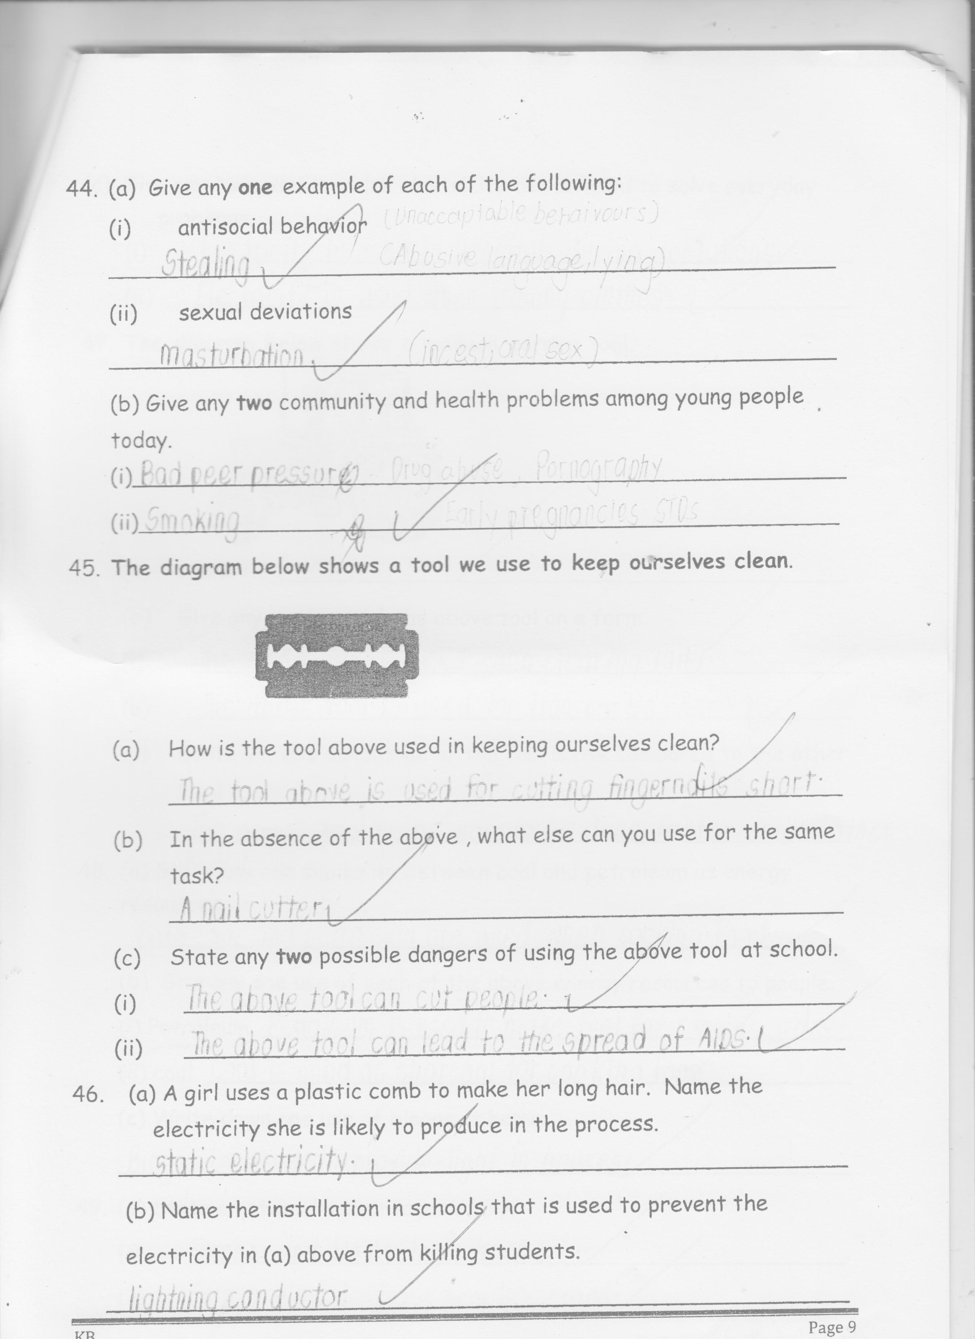

a) How is the tool above used in keeping ourselves clean?

_____________________________________________________

b) In the absence of the above, what else can you use for the same task?

_____________________________________________________

c) State any two possible dangers of using the above tool at school.

i) ___________________________________________________

ii) ___________________________________________________

1. a) A girl used a plastic comb to make her long hair. Name the electricity

she is likely to produce in the process.

_____________________________________________________

b) Name the installation in schools that is used to prevent the electricity

in (a) above from killing students.

_____________________________________________________

c) Give any two ways in which electricity can be used to solve everyday

problems. i)____________________________________________________

ii)___________________________________________________

1. **The diagram below shows a modern garden tool.**

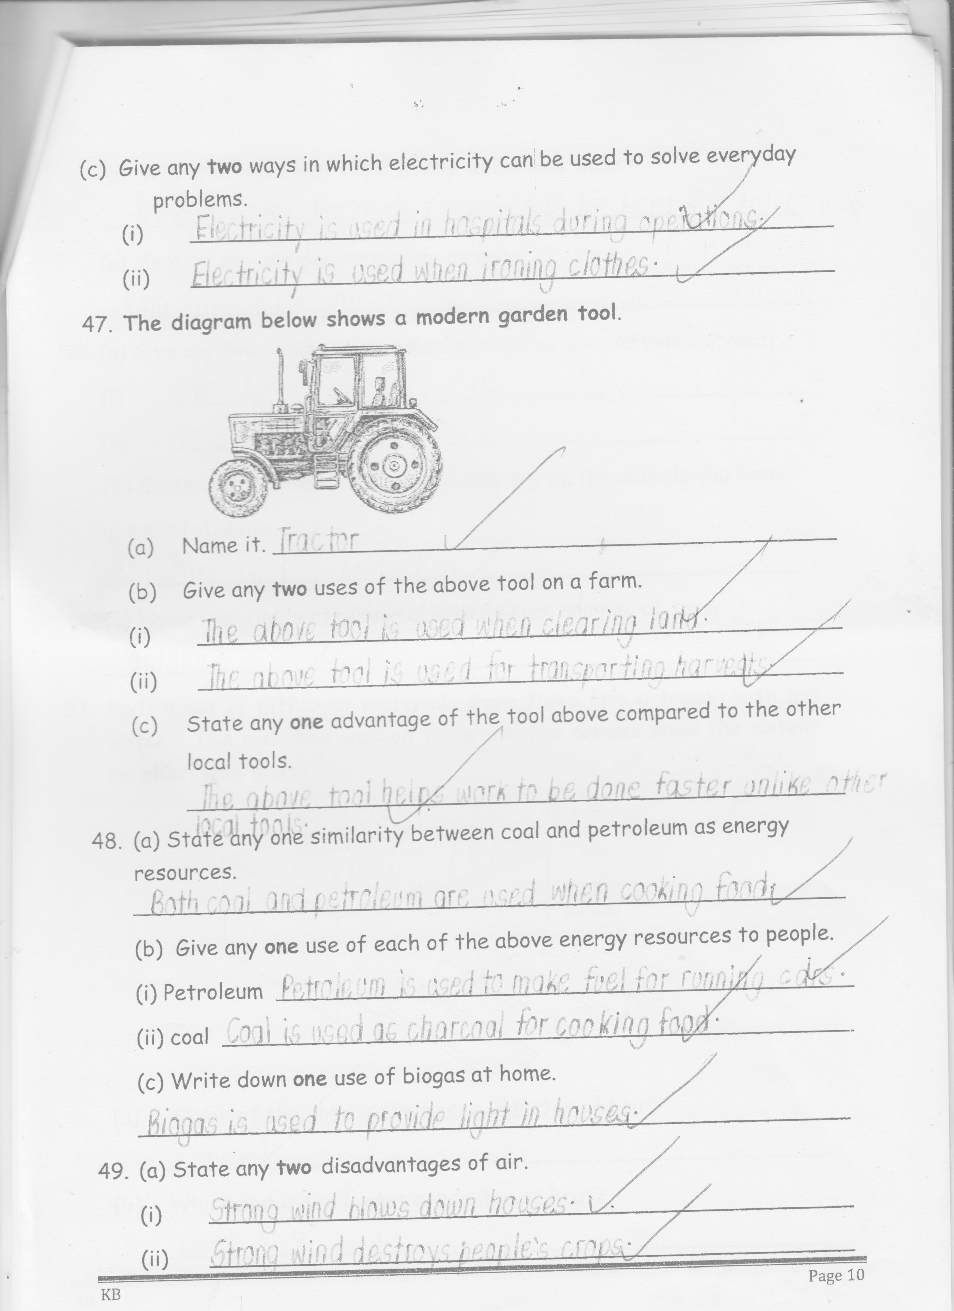

1. Name it _________________________________________
2. Give any two uses of the above tool on a farm.

i)____________________________________________________

ii)___________________________________________________

1. State any one advantage of the above compared to the other local tools.

_____________________________________________________

1. a) State any one similarity between coal and petroleum as energy

resources.

_____________________________________________________

1. Give any one use of each of the above energy resources to people.
2. Petroleum

____________________________________________________

1. Coal

______________________________________________________

1. Write down one use of biogas at home.

_____________________________________________________

1. a) State any two disadvantages of air.

i)____________________________________________________

ii)___________________________________________________

b) Why is it important for a family to harvest water?

_____________________________________________________

c) Mention any one danger of rain on soil

_____________________________________________________

_____________________________________________________

1. a) Give any two domestic animals that neither give us milk nor meat.

i)________________________________________________________

ii) _______________________________________________________

b) State any one importance of keeping any of the animals you have given

in (a) above.

_________________________________________________________

c) Name one wild hoofed animal with an even number of toes.

_________________________________________________________

1. 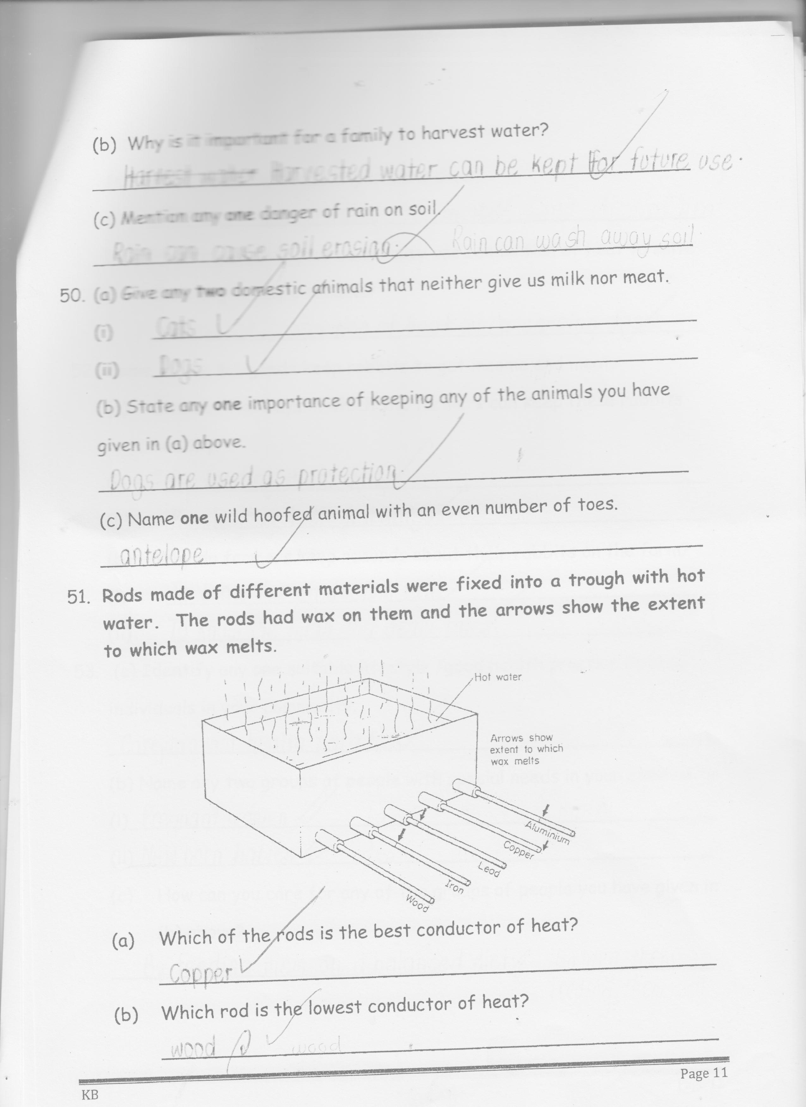**Rods made of different materials were fixed into a trough with hot water. The rods has wax on them and the arrows show the extent to which wax melts.**
2. Which of the rods is the best conductor of heat?

____________________________________________________

1. Which rod is the lowest conductor of heat?

_____________________________________________________

1. What does the above experiment show?

_____________________________________________________

1. How do people in your community use conduction of heat to solve their day to day problems?

_____________________________________________________

1. Some people in Uganda keep rabbits to get income and meat.

a) Give any two ways in which the farmers can keep these rabbits healthy

i)____________________________________________________

ii)___________________________________________________

b) Why do farmers keep records about their rabbits on the farm?

i)____________________________________________________

ii) ___________________________________________________

c) How can you care for any of the groups of people you have given in (b)

above?

i)____________________________________________________

ii)___________________________________________________

1. a) Identify any one suitable lifestyle / good health practice done by

individuals in your community.

_____________________________________________________

b) Name any two groups of people with special needs in your community.

i)____________________________________________________

ii)___________________________________________________

c) How can you care for any of the groups of people you have given in (b)

above?

_____________________________________________________

1. **The illustration below shows a food chain**

**Grass Caterpillar hen cat**

1. Which of the above living things is both a predator and a prey?

_____________________________________________________

b) What do the arrows represent in the illustration above?

_____________________________________________________

c) What general name is given to the caterpillar, hen and the cat in the

illustration above?

____________________________________________________

d) Why is grass said to be a producer?

___________________________________________________

1. Respiration is necessary for human life
2. Name any one end product and by-product of respiration
3. end-product

____________________________________________________

1. by-product

____________________________________________________

1. State any one campaign you would participate in to keep other people’s

respiratory systems in good working conditions.

____________________________________________________

c) Identify one disorder of the respiratory system.

_____________________________________________________

**END**